ILHAM SETIA BHAKTI

201810225036

TUGAS TOPIK 6 PEMROGRAMAN WEBSITE

Koneksi.php

Kode

<?php

$conn = mysqli_connect('localhost', 'root', '');

if ($conn) {echo 'Koneksi SUkses';}

?>

Output

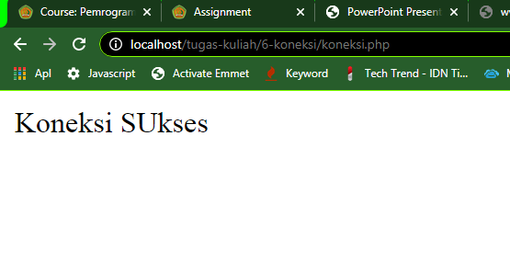

koneksidb.php

Kode

<?php

$koneksi=mysql_connect('localhost','root','')

or die ('Gagal konek server'.mysql_error());

If($koneksi) {

mysql_select_db('tugas-kuliah',$koneksi)

or die ('Database gagal dibuka'.mysql_error());

echo 'Koneksi berhasil';

}

?>

Output

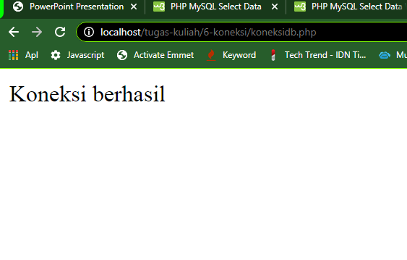

tampildata.php

Kode

<?

$koneksi=mysql_connect('localhost','root','')

or die ('Gagal konek server'.mysql_error());

If($koneksi) {

mysql_select_db('tugas-kuliah',$koneksi)

or die ('Database gagal dibuka'.mysql_error());

echo 'Koneksi berhasil';

}

$result = mysql_query('SELECT * FROM anggota',$koneksi);

while($row = mysql_fetch_array($result)) {

echo "id: " . $row["id"]. " <br/> Name: " . $row["nama"]. " <br/>" . $row["kelamin"]. "<hr>";

}

Output

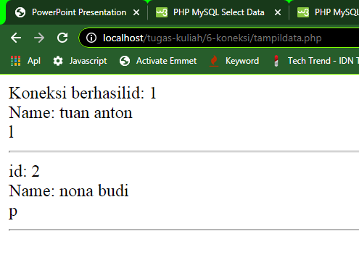

masukanform.php

Kode

<html>

<body>

<form action="masukansim.php" method="post">

<table width="25%" border="0">

<tr>

<td>ID</td>

<td><input type="text" name="id"></td>

</tr>

<tr>

<tr>

<td>Name</td>

<td><input type="text" name="name"></td>

</tr>

<td>Kelamin</td>

<td><input type="text" name="kelamin"></td>

</tr>

<tr>

<td></td>

<td><input type="submit" name="Submit" value="Add"></td>

</tr>

</table>

</form>

</body>

Output

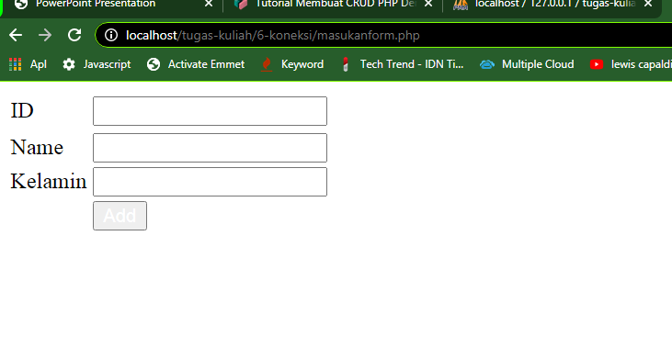

masukansim.php

Kode

<?php

$conn = mysqli_connect('localhost', 'root', '','tugas-kuliah');

if ($conn) {echo 'Koneksi SUkses';}

if(isset($_POST['Submit'])) {

$name = $_POST['name'];

$id = $_POST['id'];

$kelamin = $_POST['kelamin'];

$result = mysqli_query($conn, "INSERT INTO anggota(id,nama,kelamin) VALUES('$id','$nama','$kelamin')");

echo "Sukses Input!";

}

?>

Output

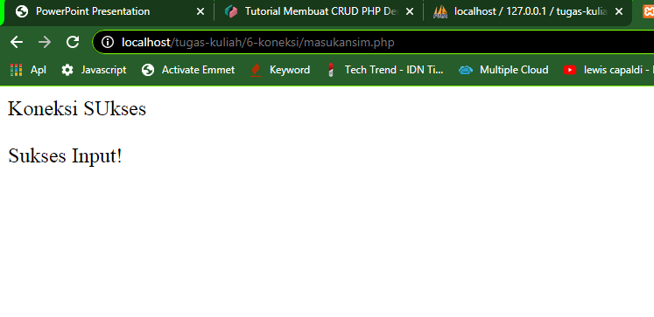

tampilhapus.php

Kode

<?

$koneksi=mysql_connect('localhost','root','')

or die ('Gagal konek server'.mysql_error());

If($koneksi) {

mysql_select_db('tugas-kuliah',$koneksi)

or die ('Database gagal dibuka'.mysql_error());

echo 'Koneksi berhasil';

}

$result = mysql_query('SELECT * FROM anggota',$koneksi);

while($row = mysql_fetch_array($result)) {

echo "<p>id: " . $row["id"]. " <br/> Name: " . $row["nama"]. " <br/>" . $row["kelamin"]. " | <a href='#'>HAPUS</a></p><hr>";

}

Output

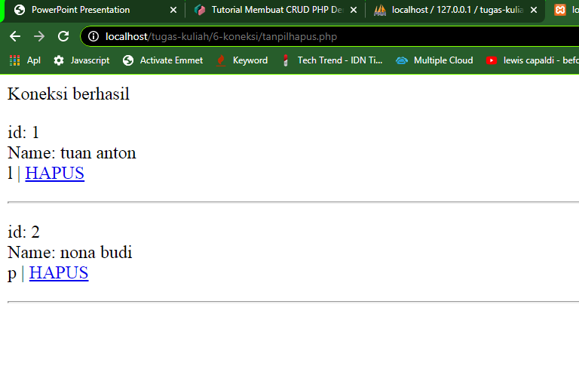

hapusdata.php

Kode

<?

$koneksi=mysql_connect('localhost','root','')

or die ('Gagal konek server'.mysql_error());

If($koneksi) {

mysql_select_db('tugas-kuliah',$koneksi)

or die ('Database gagal dibuka'.mysql_error());

echo 'Koneksi berhasil';

}

$result = mysql_query('DELETE FROM users WHERE id=$id',$koneksi);

Output

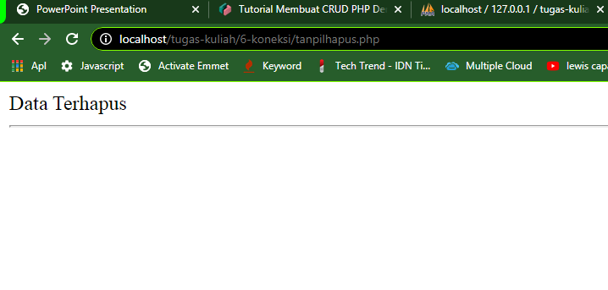

ubahtampil.php

Kode

<?

$koneksi=mysql_connect('localhost','root','')

or die ('Gagal konek server'.mysql_error());

If($koneksi) {

mysql_select_db('tugas-kuliah',$koneksi)

or die ('Database gagal dibuka'.mysql_error());

echo 'Koneksi berhasil';

}

$result = mysql_query('SELECT * FROM anggota',$koneksi);

while($row = mysql_fetch_array($result)) {

echo "<p>id: " . $row["id"]. " <br/> Name: " . $row["nama"]. " <br/>" . $row["kelamin"]. " | <a href='#'>HAPUS</a></p><hr>";

}

Output

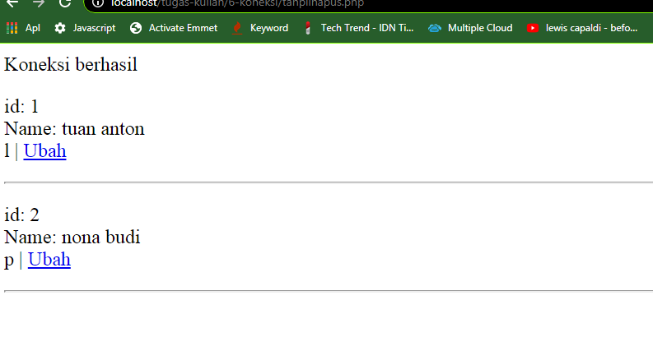

ubahdata.php

Kode

<?

$koneksi=mysql_connect('localhost','root','')

or die ('Gagal konek server'.mysql_error());

If($koneksi) {

mysql_select_db('tugas-kuliah',$koneksi)

or die ('Database gagal dibuka'.mysql_error());

echo 'Koneksi berhasil';

}

$result = mysql_query('DELETE FROM users WHERE id=$id',$koneksi);

echo 'Data Terhapus'

Output

